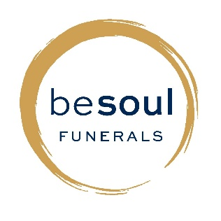

Peace of Mind: The Importance of Pre-Planning Funeral Services
Why Talk About Funerals?
- Talking about funerals helps reduce the burden on family.
- It ensures your final wishes are respected.
- Pre-planning is a caring, responsible act.
What is Funeral Pre-Planning?
- Deciding funeral preferences in advance.
- May include service type, music, readings, burial or cremation.
- Can be written informally or set up as a formal prepaid plan.
Benefits of Pre-Planning
- Reduces stress and decision-making for family.
- Provides financial certainty.
- Minimises family conflict and confusion.
- Gives peace of mind to all involved.
Key Components of a Funeral Plan
- Cremation or burial.
- Type of service: religious, military, RSA-related.
- Venue, music, readings, eulogies.
- Flowers or charity donations.
- Headstone or memorial preferences.
Financial Planning Options
- Prepaid funeral plans.
- Funeral insurance, savings, or Trusts.
- Consult financial or legal advisors.
Talking to Loved Ones
- Choose a calm time to talk about your plans.
- Be open and honest.
- Write things down and store with your will.
Common Myths
- “It’s too early to plan.” → Planning ahead is wise.
- “My family will know what to do.” → Often, they won’t.
- “It’s too morbid.” → It’s actually a relief for everyone.

How can the RSA or Other Services offer Support
- Chaplain or staff support.
- Help with military honours.
- Use of RSA venues.
- Community and emotional support.
Getting Started
- Reflect on your values.
- Talk to your family.
- Speak with a funeral director.
- Create or update your will.
- Store important documents safely.

Contact:
besoul Funerals
Lily Watson – Funeral Director
12 Gumfield Drive, Warkworth 0910
Ph: 09 422 2534
Email: lily@besoul.co.nz

